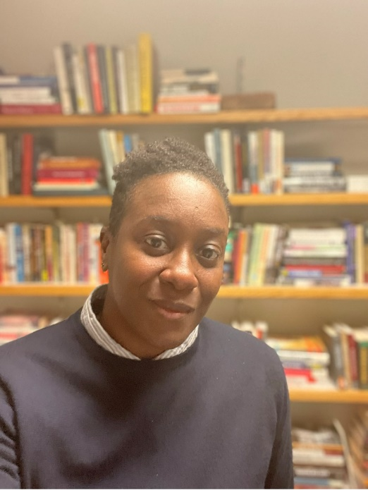

Brief Bio
Sylvea Hollis is an Assistant Professor in African American History at Montgomery College. She earned a Ph.D. in US History from the University of Iowa. Before coming to Montgomery College, Dr. Hollis was a National Park Service-Mellon Postdoctoral Fellow and taught courses in gender and sexuality in the American Studies Department at The George Washington University. She earned a MA in History Museum Studies from the Cooperstown Graduate Program (SUNY-Oneonta) and has a BS in History from the University of Montevallo, a small public liberal arts institution in Alabama.

Longer Bio
Sylvea Hollis is an Assistant Professor in African American History at Montgomery College. She earned a Ph.D. in US History from the University of Iowa.
Before coming to Montgomery College in the fall of 2020, Dr. Hollis was a National Park Service-Mellon Postdoctoral Fellow and taught courses in gender and sexuality in the American Studies Department at The George Washington University. She earned a MA in History Museum Studies from the Cooperstown Graduate Program (SUNY-Oneonta) and has extensive experience in the museum field. Her most current work is a research project on the “Birmingham Years” of the African American sculptor, John W. Rhoden, for a forthcoming exhibition catalog with the Pennsylvania Academy of Fine Arts. Dr. Hollis also runs a blog (http://www.sylveahollis.com) that explores the intersections between African American history, archives, public humanities, and teaching.

